Knight’s Quest GDD
Project and game overview
Players will control a Knight who finds himself washed ashore on a mysterious island filled with skeletons and other classic fantasy monsters.
3rd person action game. Summary
- Concept- SoulsLike game where the player switches between a long range and short range attack option
- Genre – SoulsLike/ActionAdventure
- Art – LowPoly, Medieval Fantasy aesthetic
- Platform – PC
- Target Audience - people who like a challenge, fans of the genre

Player – knight
- Weapon Switches between sword and whip/chain mode with varying move sets
- Level up weapon increase move slots
- Sword Moves
  - Focus on high single target damage at the cost of safety
  - Basic Swing – cost stamina, no equip slot/always active
  - Overhead – cost stamina + mana, must be equipped, does extra damage, deals high stun damage
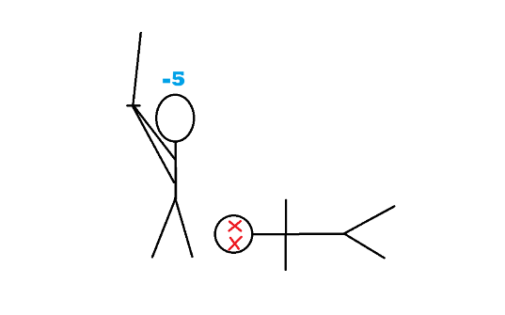
- Whip Moves
  - Focus on range and the safety that provides and attacking multiple enemies at once with wide sweeping attacks at the cost of damage.
  - Basic Swing – cost stamina + mana, no equip slot/always active
  - Spin– cost stamina + mana, must be equipped, larger area of attack
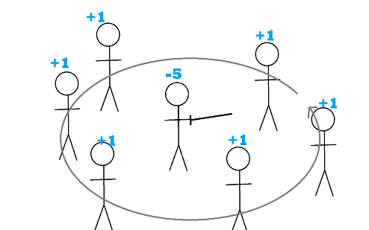
- Mana - The player will gain mana every time they hit an enemy.
- Healing:
The player will have three healing slots by default.
The player can use a full mana bar to recover all three healing slots.
- Shield/parry
- They player can activate a magical shield while in sword mode.
- This shield will drain mana every second it is active
  - The shield will block 100% of damage initially but deteriorate over time as it is active with the amount of blocked damage dropping.
  - The 100% shield will also parry the enemies attack stunning them as well as giving the player mana
- Experience points
  - Gained from killing enemies
  - Lost on death
  - Use to level up
- Level up
- Health
- Stamina
- Mana
- Strength – sword mode damage
- Dexterity – whip mode damage
Game elements
Enemy list
- A skeleton, a low health mob style enemy with many attacking at once.
- A zombie/ghoul, a middling health enemy that will vary between single and multiple enemies depending on player progression. A Ranged/bow variant of this enemy may be implemented depending on timing (very low priority)
- The Rusted Knight that will act as the high health armoured enemy.

Level
    - Style – beach/forest
    - Skeletons primary enemy
    - Zombie secondary
    - Overhead + spin attack as treasure
    - Rusted Knight enemy as boss.
    - Weapon upgrade as boss reward
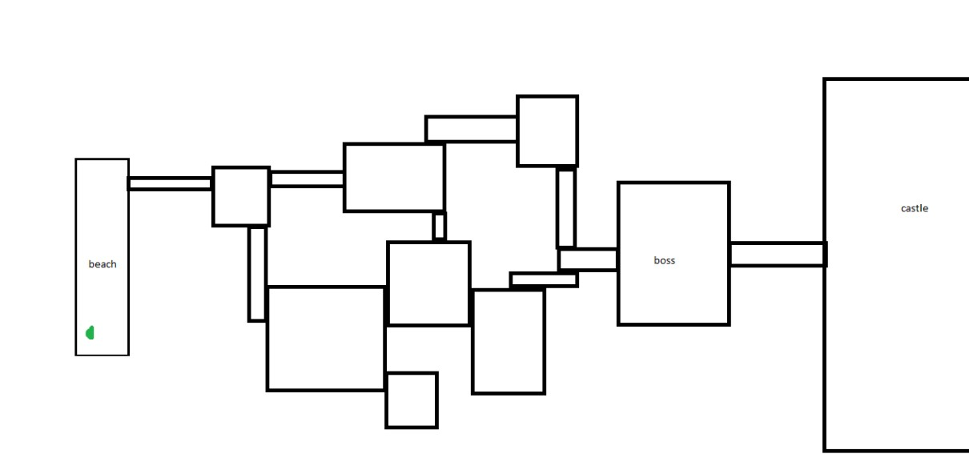

Assets (music, sound effects, 2D/3D models, effects etc.):
3d models
  - Knight
- Grey + blue – player
- Brown – rusted knight enemy
  - Skeleton
  - Base human
o Green – zombie
o Black underlayer of Knight
  - Chest
  - Sword + chain
  - Tree
- Regular
- Bent
- No leaves
A later castle level was removed following feedback regarding scope.
Player feedback also indicated that too much of the beach/forest level looked the same and some of the models being used for landmarks might help.
  - Castle -Walls, roof, Tower, Gate, Door
2d Art
- Menu
  - Title
  - Selected
  - Optional Attack moves
- Spin
- Overhead
- UI
- Bar – health, stamina, mana
- Healing pots
- Weapon mode
- Enemy health bar
- Experience points
- Boss healthbar
Sound
- Sword
- Hit
- Swing
- Switch mode
- Chest/door opening
- Grass walking
- Stone walking
- Shield
  - Active
  - parry
UI (in-game, menus, camera ,controls, etc.)
Camera
- Regular
- Follow & look at player
- Full control
- Lock-on
- Follow player
- Look at lock on target
- Up/down control
- No left/right control
UI
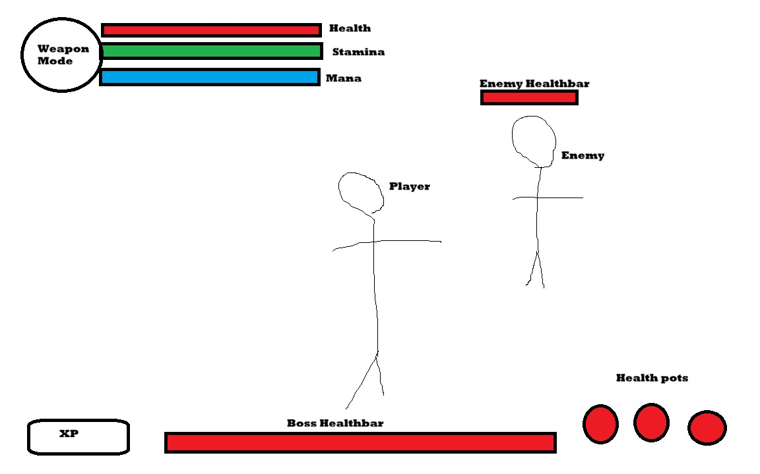
Menu
- Main
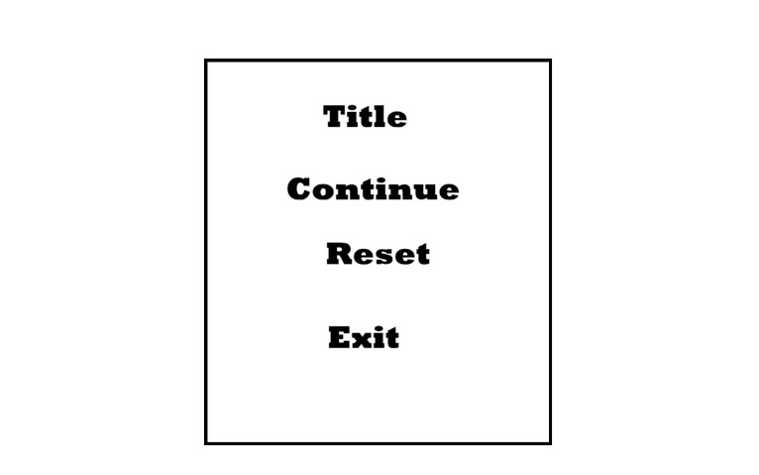
- Pause menu
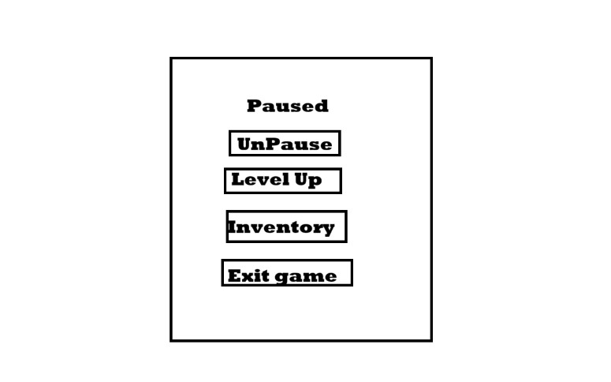
- Inventory
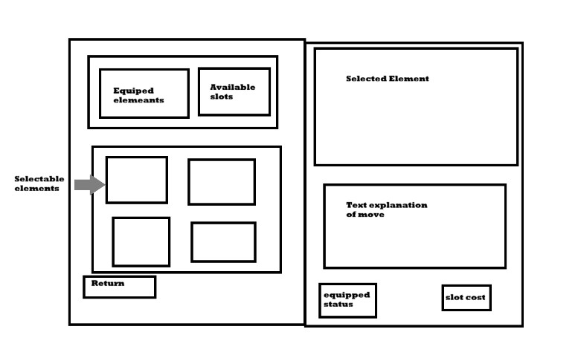
- Level Up
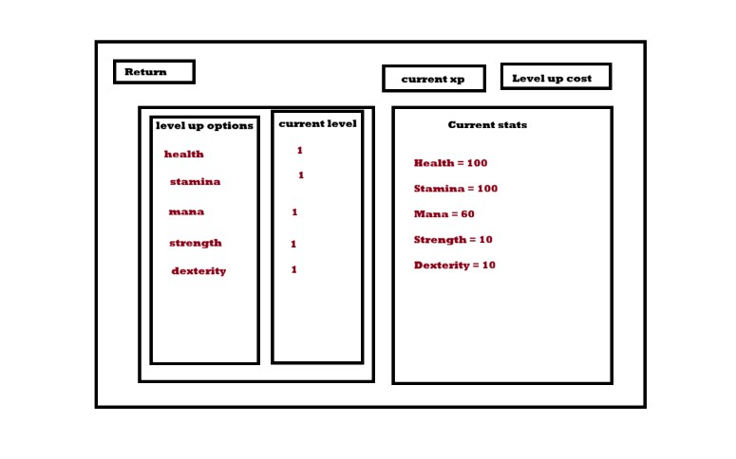

Plan
Alpha (9th March)
- all player functions
- dodge - Complete
- block – code complete
- parry – no animation/code
- level up (health, stamina, mana, damage) – code complete. Implementation needed (25th Feb)
- Enemy functions
- Armor (flat damage reduction by enemy type) (27th Feb)
- Stun/react to block (3rd April)
- Fix sword hitbox? (9th March)
- Level functions
- Door (code only/animation/model not needed) (6th March)
- Level state saved/door stay open (8th March)

Beta (13th April)
Release (27th April)

